Machine Learning

FINAL PROJECT INCREMENT

LAHARI REDDY MUSKULA

700741333

**Manually Cleaning the data-set in CSV format:**

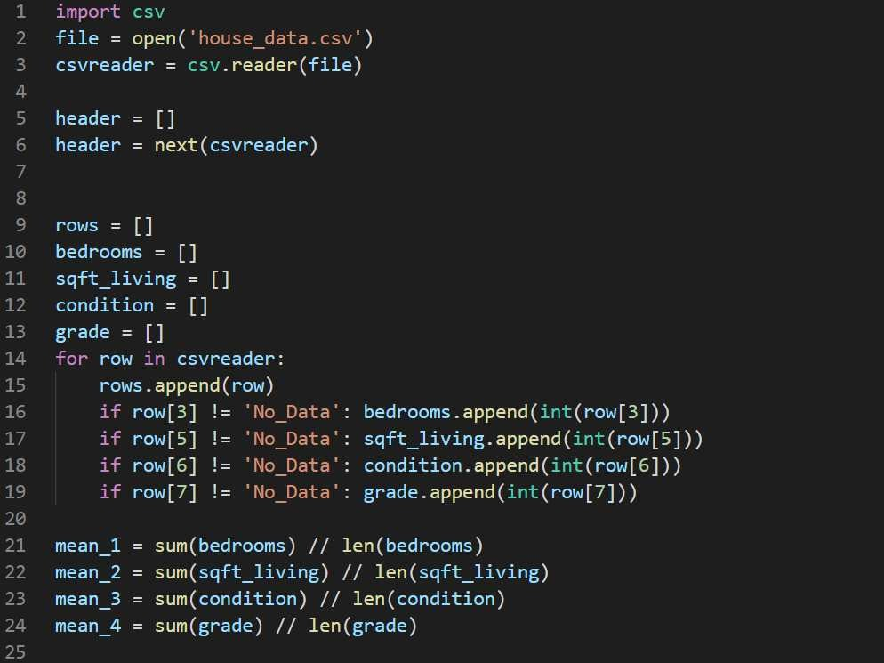

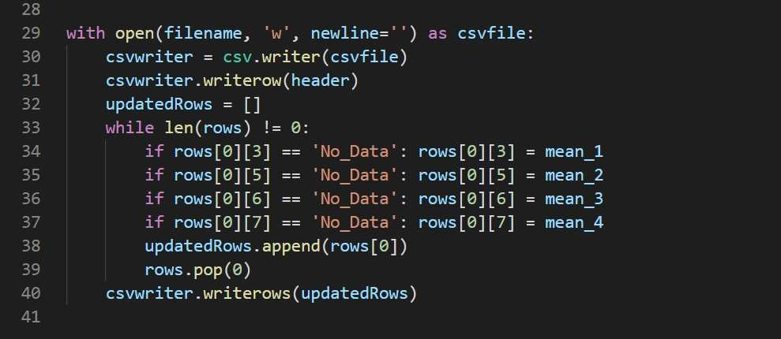

**Cleaning the data-set using Pandas and NumPy:**

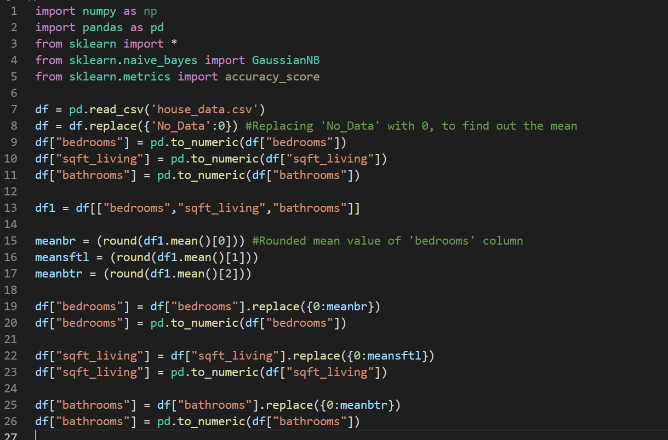

**Code for making graphical analysis in the application:**

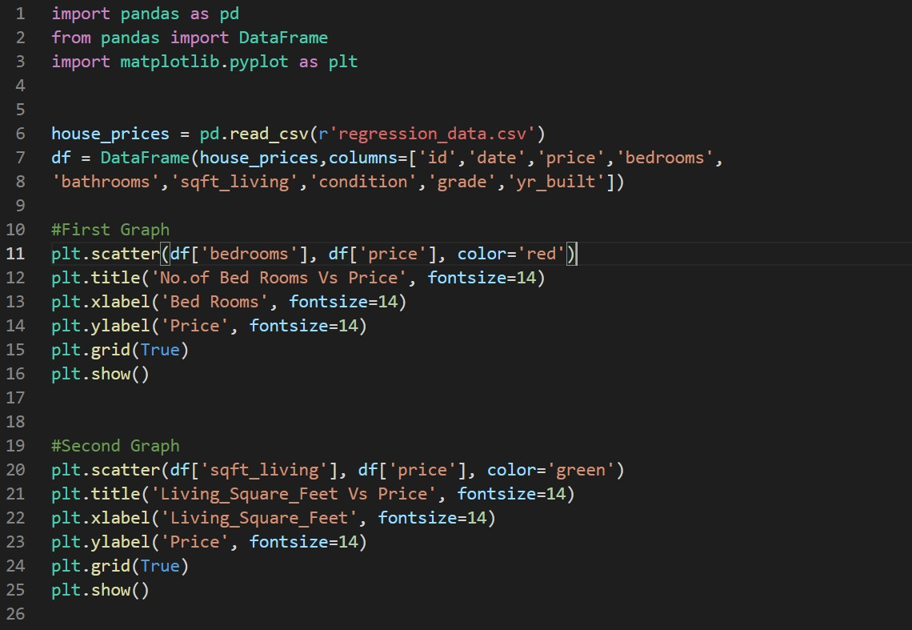

**Outputs for the Graph code:**

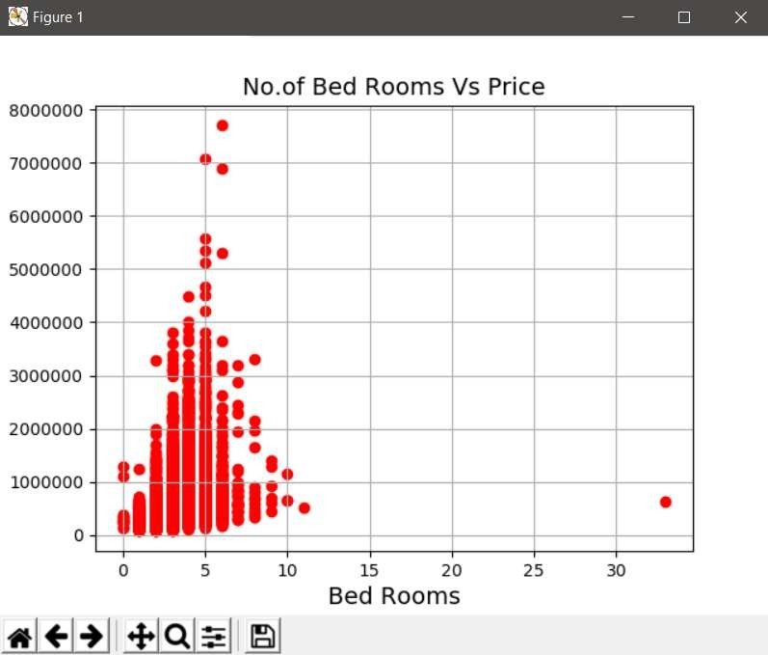

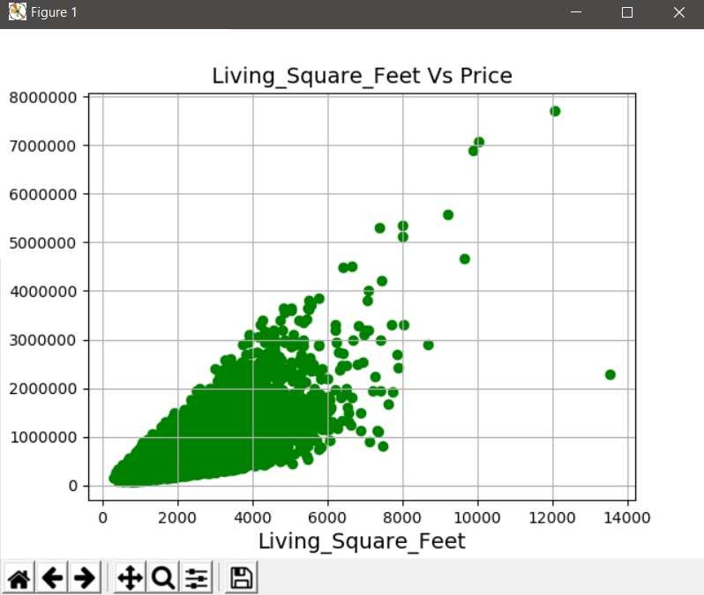

## Gaussian Naïve Bayes Classifier

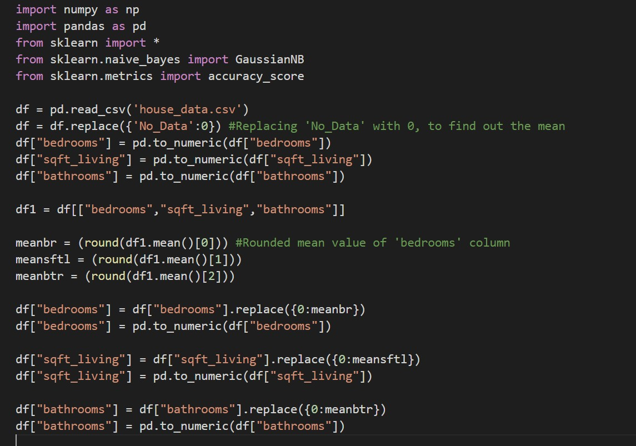

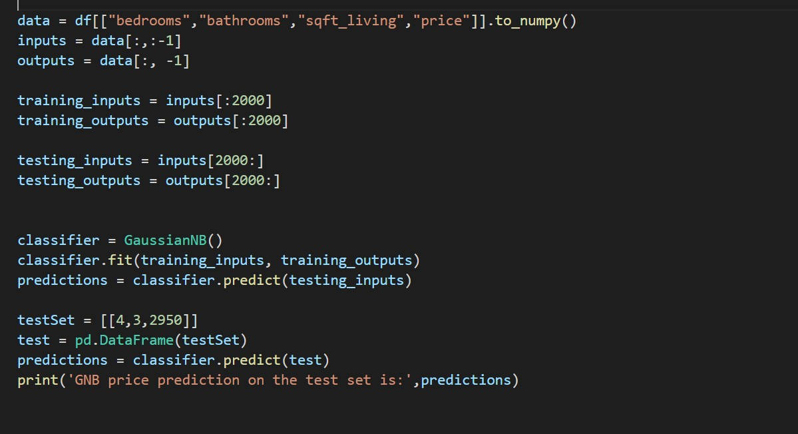

## Decision Tree Classifier

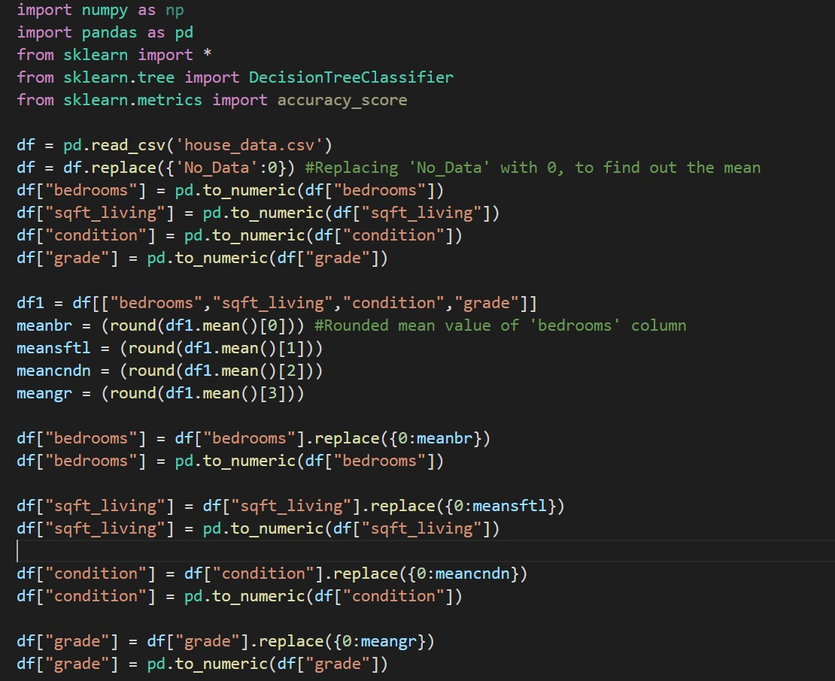

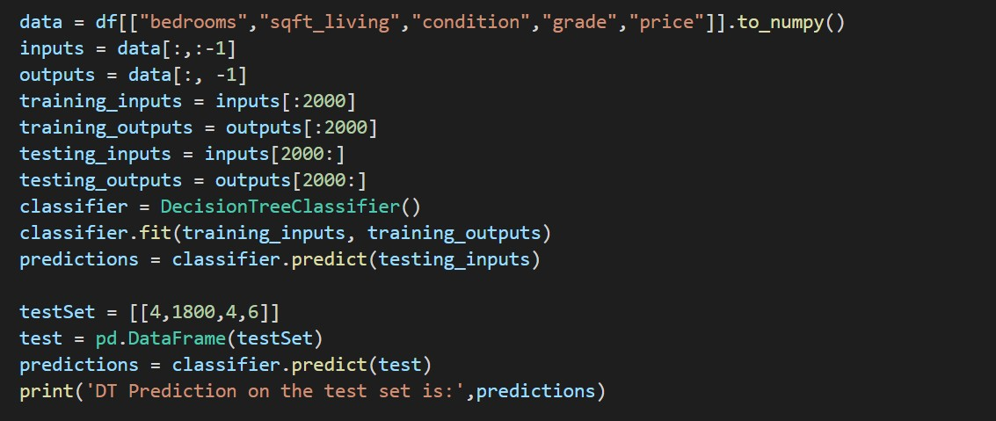

## Regression Predictor

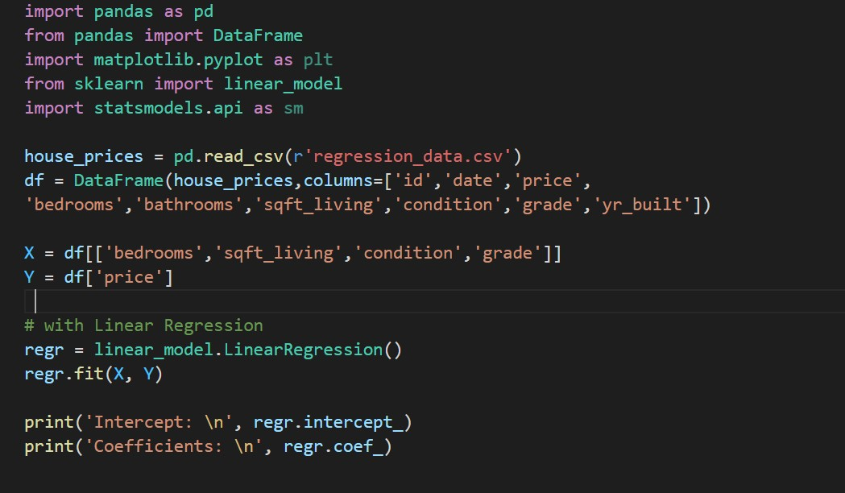

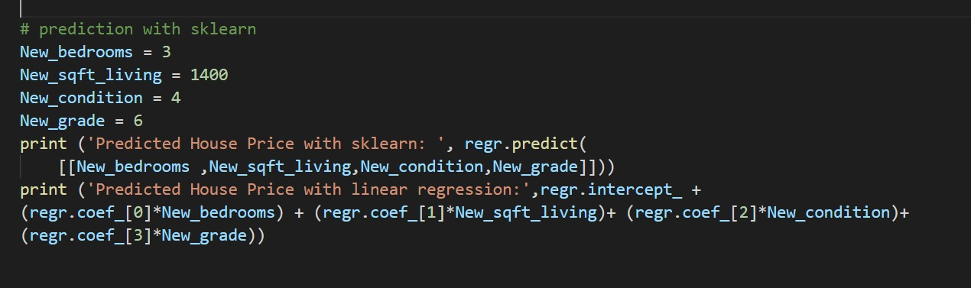

## Splitting the data and comparing

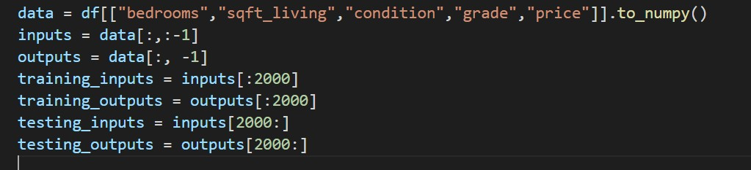

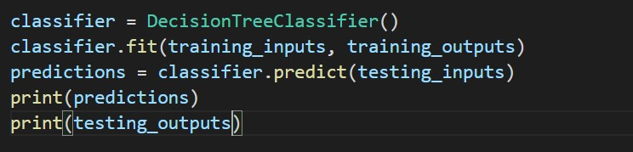

# RESULT ANALYSIS

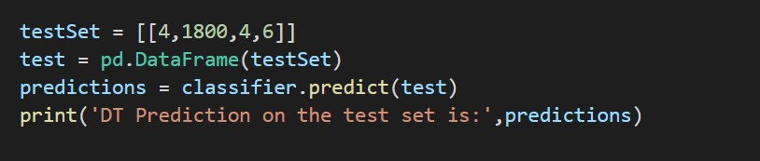

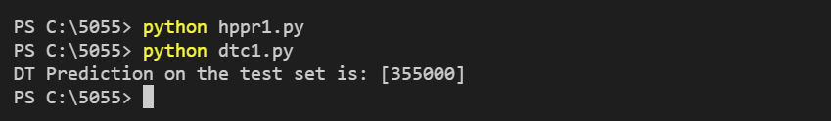

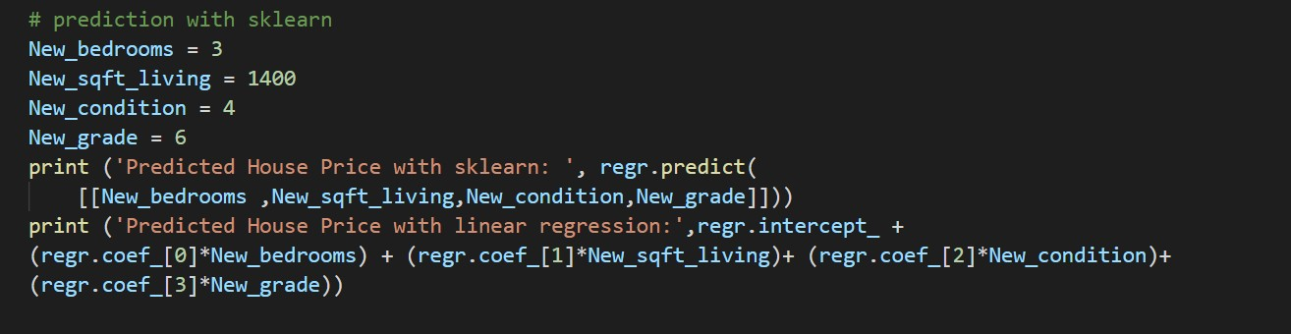

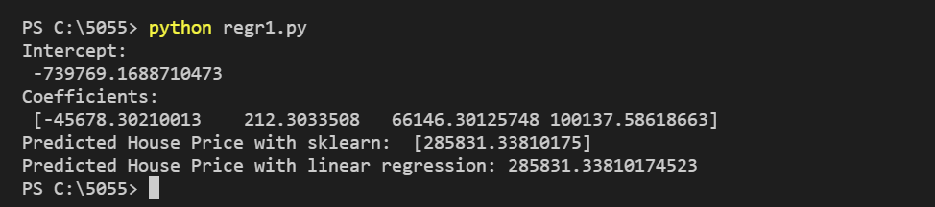

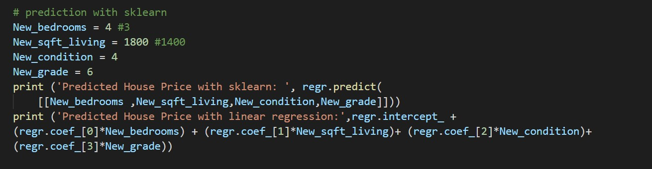

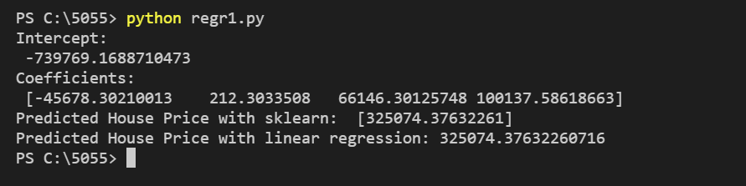

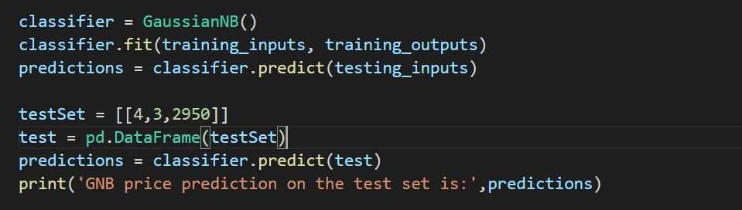

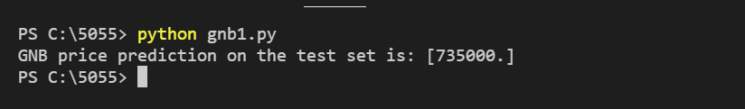

THANK YOU